Corel Draw export to LightBurn
- Open the Macro Manager
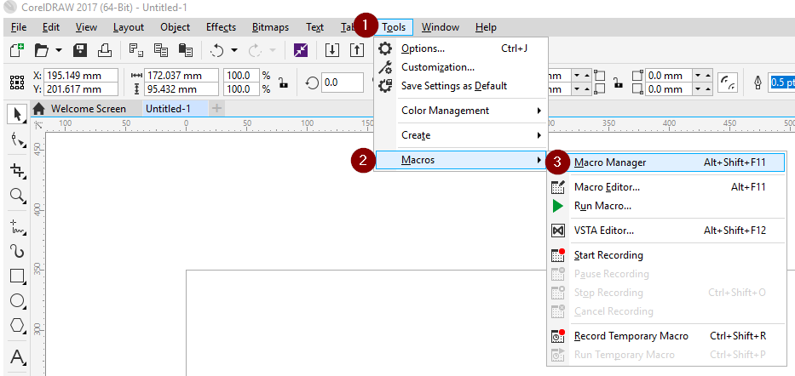

- Create a new module in the GlobalMacros project
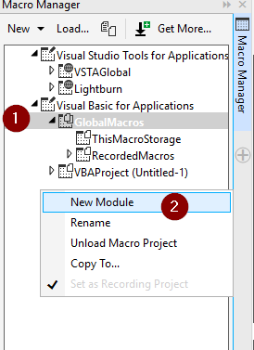
- Name the new module lightburn and right click and select edit. 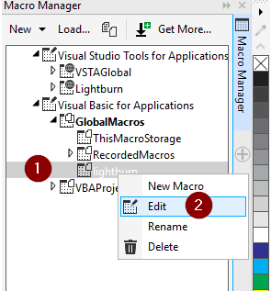

- Copy the following into the open page

Sub Lightburn()
Dim answer As Integer
Dim OrigSelection As ShapeRange
Set OrigSelection = ActiveSelectionRange
OrigSelection.CreateSelection
Dim expopt As StructExportOptions
Set expopt = CreateStructExportOptions
expopt.UseColorProfile = True
Dim expflt As ExportFilter

Dim out_file As String
out_file = "C:" & Environ("HOMEPATH") & "\export.ai"
If Len(Dir$(out_file)) > 0 Then
Kill (out_file)
End If

' is an item selected?
If ActiveSelectionRange.Count > 0 Then
' something is selected export it
Set expflt = ActiveDocument.ExportEx(out_file, cdrAI, cdrSelection, expopt)
With expflt
.Version = 10 ' FilterAILib.aiVersionCS6
.TextAsCurves = True
.PreserveTransparency = True
.ConvertSpotColors = True
.SimulateOutlines = False
.SimulateFills = False
.IncludePlacedImages = True
.IncludePreview = True
.EmbedColorProfile = True
.Finish
End With

Else
answer = MsgBox("Nothing was selected, Export All?", vbYesNo + vbQuestion, "Export All")
If answer = vbYes Then
' Export everything
Set expflt = ActiveDocument.ExportEx(out_file, cdrAI, cdrAllPages, expopt)
With expflt
.Version = 10 ' FilterAILib.aiVersionCS6
.TextAsCurves = True
.PreserveTransparency = True
.ConvertSpotColors = False
.SimulateOutlines = False
.SimulateFills = False
.IncludePlacedImages = True
.IncludePreview = True
.EmbedColorProfile = True
.Finish
End With

Else
'do nothing
Exit Sub
End If
End If

' Edit this like if lightburn is in a diffrent location
Call Shell("C:\Program Files\LightBurn\LightBurn.exe " & out_file, vbNormalFocus)
End Sub

It should look like this.
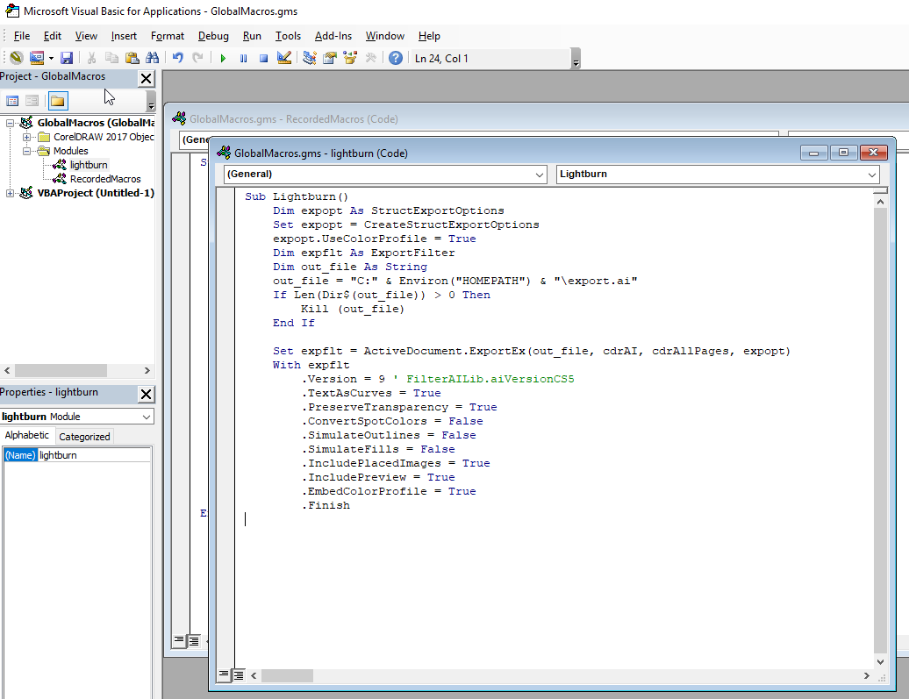
- Close the macro editor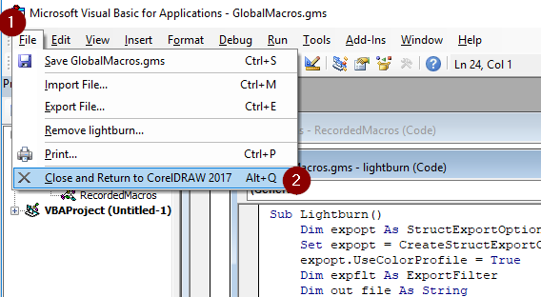
- Now we need to add the button to the toolbar. Open the options menu. 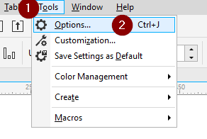
- Select commands under the customization section and make sure the macro option is selected in the drop-down. Then drag the lightburn.lightburn macro to the toolbar.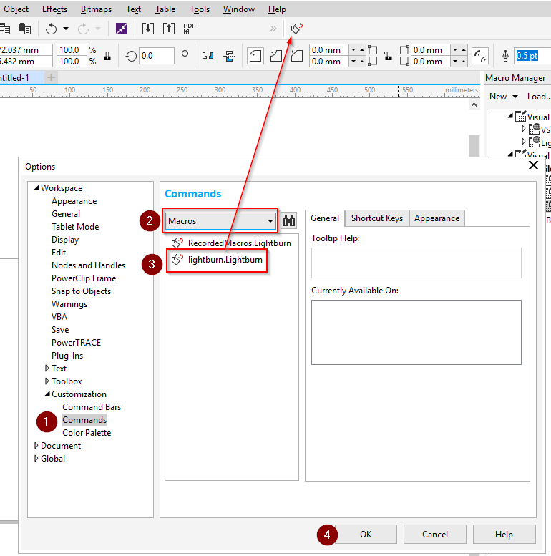
  - Optional: Change Icon.
Select the Appearance tab and select the lightburn macro. download logo.ico from the files section in the facebook group. Click the browse buttion and select logo.ico. you can also set a caption which will change lightburn.lightburn to anything you want.
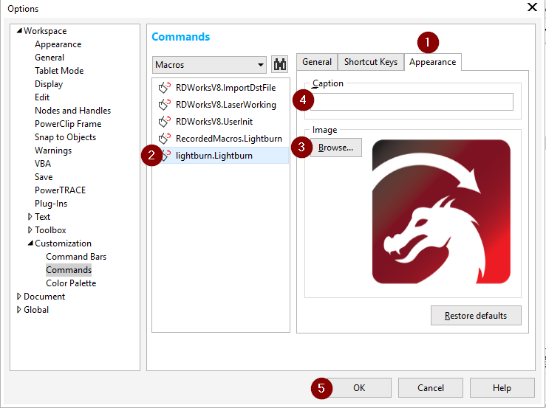

- Now select the objects you want and click the button and Lightburn will be opened and the objects will be auto-imported.

